Urban Legends Part II MAVO/HAVO/VWO
We’re going to read two Urban Legend stories again. This time the stories are a bit more gruesome…
First read the text, then answer the questions.


Text I - The Hitchhiker
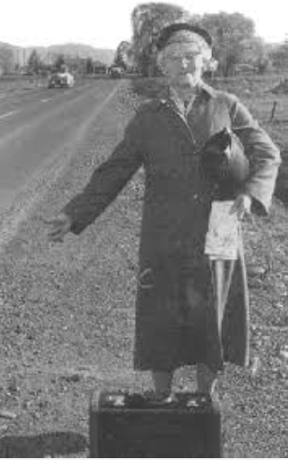
As Andrea turned off the motorway onto the road to Brockbourne, the small village in which she lived, it was four o'clock in the afternoon, but already the sun was falling behind the hills. At this time in December, it would be completely dark by five o'clock. Andrea shivered. The interior of the car was not cold, but the trees bending in the harsh wind and the patches of yesterday's snow still heaped in the fields made her feel chilly inside. It was another ten miles to the cottage where she lived with her husband Michael, and the dim light and wintry weather made her feel a little lonely. She would have liked to listen to the radio, but it had been stolen from her car when it was parked outside her office in London about two weeks ago, and she had not got around to replacing it yet.

She was just coming out of the little village of Mickley when she saw the old lady, standing by the road, with a crude hand-written sign saying "Brockbourne" in her hand. Andrea was surprised. She had never seen an old lady hitchhiking before. However, the weather and the coming darkness made her feel sorry for the lady, waiting hopefully on a country road like this with little traffic. Normally, Andrea would never pick up a hitchhiker when she was alone, thinking it was too dangerous, but what was the harm in doing a favour for a little old lady like this?
Andrea pulled up a little way down the road, and the lady, holding a big shopping bag, hurried over to climb in the door which Andrea had opened for her.
When she did get in, Andrea could see that she was not, in fact, so little. Broad and fat, the old lady had some difficulty climbing in through the car door, with her big bag, and when she had got in, she more than filled the seat next to Andrea. She wore a long, shabby old dress, and she had a yellow hat pulled down low over her eyes. Panting noisily from her effort, she pushed her big brown canvas shopping bag down onto the floor under her feet, and said in a voice which was almost a whisper;

"Thank you dearie -- I'm just going to Brockbourne."
"Do you live there?" asked Andrea, thinking that she had never seen the old lady in the village in the four years she had lived there herself.
"No, dearie," answered the passenger, in her soft voice, "I'm just going to visit a friend. He was supposed to meet me back there at Mickley, but his car won't start, so I decided to hitchhike -- there isn't a bus until seven, and I didn't want to wait. I knew some kind soul would give me a lift."

Something in the way the lady spoke, and the way she never turned her head, but stared continuously into the darkness ahead from under her old yellow hat, made Andrea uneasy about this strange hitchhiker. She didn't know why, but she felt instinctively that there was something wrong, something odd, something....dangerous. But how could an old lady be dangerous? it was absurd.

Careful not to turn her head, Andrea looked sideways at her passenger. She studied the hat, the dirty collar of the dress, the shapeless body, the arms with their thick black hairs.... Thick black hairs? Hairy arms? Andrea's blood froze. This wasn't a woman. It was a man. At first, she didn't know what to do. Then suddenly, an idea came into her racing, terrified brain. Swinging the wheel suddenly, she threw the car into a skid, and brought it to a halt.

"My God!" she shouted, "A child! Did you see the child? I think I hit her!"
The "old lady" was clearly shaken by the sudden skid. "I didn't see anything dearie," she said. "I don't think you hit anything."

"I'm sure it was a child!" insisted Andrea. "Could you just get out and have a look? Just see if there's anything on the road?" She held her breath. Would her plan work?

It did. The passenger slowly opened the car door, leaving her bag inside, and climbed out to investigate. As soon as she was out of the vehicle, Andrea gunned the engine and accelerated madly away. The car door swung shut as she rounded a bend, and soon she had put a good three miles between herself and the awful hitchhiker.

It was only then that she thought about the bag lying on the floor in front of her. Maybe the bag would provide some information about the real identity about the old woman who was not an old woman. Pulling into the side of the road, Andrea lifted the heavy bag onto her lap and opened it curiously.
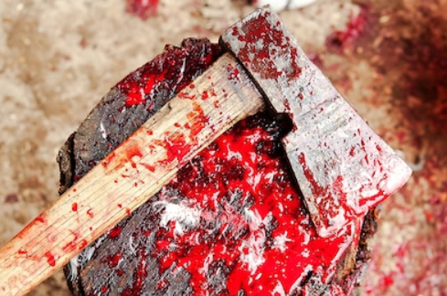
It contained only one item -- a small hand axe, with a razor-sharp blade. The axe, and the inside of the bag, were covered with the dark red stains of dried blood.

Andrea began to scream.

MDH 1994 -- From a common urban legend

Questions - The Hitchhiker MAVO/HAVO/VWO
Write down words you don’t know yet and look for their translation.
English | Dutch | English | Dutch
MAVO
Answer the questions about the Hitchhiker in English.
- Andrea usually picks up hitchhikers. True or false? Copy the sentence that gives you the answer.
- Why did Andrea stop to pick up the old lady who was standing by the road?
- What was strange about the old lady who stepped into the car? Name at least 1 thing.
- Andrea hit a child when they were driving to Brockbourne. True or false? Copy the sentence that gives you the answer.
- What was inside the old lady’s bag?
HAVO
Answer the following questions about the Hitchhiker in English. Answer in full sentences.
- How did Andrea feel about picking up hitchhikers?
- Why did Andrea stop to pick up the old lady who was standing by the road?
- What was strange about the old lady who stepped into the car? Name at least 2 things.
- Why did Andrea throw the car into a skid and said she had hit a child?
- Why did Andrea begin to scream when she opened the old lady’s bag?
VWO
Answer the following questions about the Hitchhiker in English. Answer in full sentences.
- How did Andrea feel when she was driving home? What made her feel this way?
- Why did Andrea change her mind about picking up hitchhikers when she saw the old lady standing by the road?
- What was strange about the old lady who stepped into the car? Name at least 2 things.
- Why did Andrea throw the car into a skid and said she had hit a child?
- Why did Andrea open the old lady’s bag?

Text II - The American pepper
"Mummy! Mummy!" shouted little Murna racing from the front door through to the kitchen. "There's a parcel. The postman's brought a parcel!"
Her mother, Savni, looked at her in surprise. She had no idea who could have sent them a parcel. Maybe it was a mistake. She hurried to the door to find out. Sure enough, the postman was there, holding a parcel about the size of a small brick.

"From America, madam," he said. "See! American stamps." It was true. In the top right-hand corner of the brown paper parcel were three strange-looking stamps, showing a man's head. The package was addressed to Savni, in big, clear black letters. "Well, I suppose it must be from Great-Aunt Pasni," said Savni to herself, as the postman went on his way down the street, whistling. "Although it must be twenty years since we heard anything from her. I thought she would have been dead by now."
Savni's husband Jornas and her son Arinas were just coming in from the garden, where Murna had run to tell them about the parcel. "Well, open it then!" said Arinas impatiently. "Let's see what's inside!" Setting the parcel down in the middle of the table, Savni carefully began to tear open the paper. Inside, there was a large silver container with a hinged lid, which was taped shut. There was also a letter.
"What is it? What is it?" demanded Murna impatiently. "Is it a present?" "I have no idea," said Savni in confusion. "I think it must be from Great-Aunt Pasni. She went to America almost thirty years ago now. But we haven't heard from her in twenty years. Perhaps the letter will tell us." She opened the folded page cautiously, then looked up in dismay. "Well, this is no help!" she said in annoyance. "It's written in English! How does she expect us to read English? We're poor people, we have no education. Maybe Pasni has forgotten her native language, after thirty years in America."
"Well, open the pot, anyway," said Jornas. "Let's see what's inside." Cautiously, Savni pulled the tape from the neck of the silver pot, and opened the lid. Four heads touched over the top of the container, as their owners stared down inside.
"Strange," said Arinas. "All I see is powder." The pot was about one-third full of a kind of light-grey powder. "What is it?" asked Murna, mystified. "We don't know, darling," said Savni, stroking her daughter's hair. "What do you think?" Murna stared again into the pot.
"I think it's coffee," she announced, finally. "American coffee."
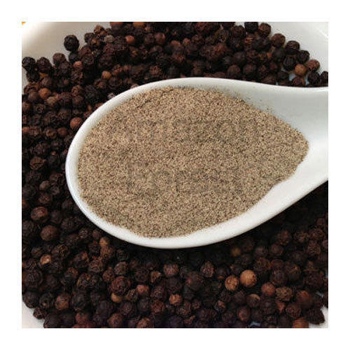
"It's the wrong colour for coffee, darling," said Jornas thoughtfully. "But maybe she's on the right track. It must be some kind of food." Murna, by now, had her nose right down into the pot. Suddenly, she lifted her head and sneezed loudly. "Id god ub by doze," she explained.
"That's it!" said Arinas. "It must be pepper! Let me try some." Dipping a finger into the powder, he licked it. "Yes," he said, "it's pepper all right. Mild, but quite tasty. It's American pepper." "All right," said Savni, "we'll try it on the stew tonight. We'll have American-style stew!"
That evening, the whole family agreed that the American pepper had added a special extra taste to their usual evening stew. They were delighted with it. By the end of the week, there was only a teaspoonful of the grey powder left in the silver container. Then Savni called a halt.
"We're saving the last bit for Sunday. Dr. Haret is coming to dinner, and we'll let him have some as a special treat. Then it will be finished." The following Sunday, the whole family put on their best clothes, ready for dinner with Dr. Haret. He was the local doctor, and he had become a friend of the family many years before, when he had saved Arinas's life after an accident. Once every couple of months, Savni invited the doctor for dinner, and they all looked forward to his entertaining stories of his youth at the university in the capital.
During dinner, Savni explained to the doctor about the mysterious American pepper, the last of which she had put in the stew they were eating, and the letter they could not read.
"Well, give it to me, give it to me!" said the doctor briskly. "I speak English! I can translate it for you."
Savni brought the letter, and the family waited, fascinated, as the doctor began to translate.
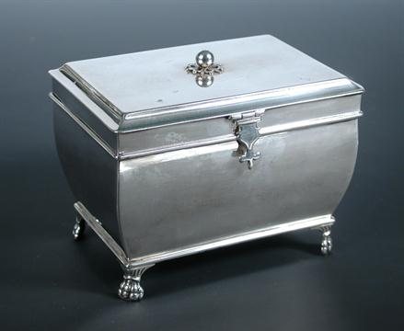
"Dear Savni: you don't know me, but I am the son of your old Great-Aunt Pasni. She never talked much to us about the old country, but in her final illness earlier this year, she told us that after her death, she wanted her ashes to be sent back home to you, so that you could scatter them on the hills of the country where she was born. My mother died two weeks ago, and her funeral and cremation took place last week. I am sending her ashes to you in a silver casket. Please do as she asked, and spread them over the ground near where she was born. Your cousin, George Leary."

MDH 1995 -- from a common urban legend

Questions - The American pepper MAVO/HAVO/VWO
Write down words you don’t know yet and look for their translation.
English | Dutch | English | Dutch
MAVO/HAVO
Answer the following questions about the American Pepper in English.
- How big is the family where the story takes place? Write down all the names of the family members.
- Where do you think this story takes place? Why do you think that?
- Why did Savni think there had been made a mistake when the postman delivered them a parcel?
- Why did Savni think her great-aunt Pasni was dead?
- Why couldn’t the family read the letter?
- What do you think their language is, if it’s not English?
- What did the family think was inside the pot eventually?
- What did they do with the powder?
- What was actually inside the pot?
VWO
Answer the following questions about the American Pepper in English.
- Write down the names of all the different family members in this story and write down how they are related.
- Where do you think this story takes place? Why do you think that? Try to give several reasons.
- Why was Savni surprised to receive a parcel?
- Why did Savni think the parcel was from her great-aunt Pasni.
- Why did Savni think Pasni was dead?
- Why couldn’t the family read the letter?
- Why had the family never learnt the English language?
- What language do you think the family speaks? Why do you think that?
- What did the family think was inside the pot? Name 2 things.
- What did they do with its content?
- Why did they save a bit of the powder?
- What did the powder end up to be?
- Is it legal to send this through the mail? Look it up online.

